Public Buildings Portfolio Management Plan Template
A Guide for Communities to Develop a Strategic Energy Plan

[this page intentionally blank]

Table of Contents
1. Introduction 2
2. Stakeholder Engagement 3
The Energy Team and Energy Champion 3
Energy Team Meetings 4
Stakeholder Drivers 5
3. Goal Setting and Vision 7
Goal Setting 7
4. Benchmarking and Data Analysis 9
Energy Data Collection 10
Master Facility Equipment List 11
5. Diagnostics 12
Step 1: Portfolio-Level Data Visualization 12
Step 2: Building-Level Diagnostics 14
Step 3: Portfolio-Level Diagnostics 16
6. Targeted Field Analysis 19
Facility Assessments 19
Prioritize Buildings 19
Field Analysis 19
7. Implementation 21
Criteria for Existing Building Upgrades 21
Schedule for Upgrades 21
Operational Policies 22
ROI Analysis for Capital Investments 22
Tracking Energy Efficiency Upgrade Impacts 22
Performance Standards for New Buildings 23
Financing Mechanisms 23
8. Ongoing Monitoring 26
Occupant Engagement 26
Community Engagement 26
9. Conclusion 28
10. Resources 29

Instructions to the User: This template document contains text highlighted in yellow with instructions. These instructions should be deleted once the document is complete. Feel free to insert new content, revise, cut content, or otherwise make this your own. Much of the other text (not highlighted) throughout this document is intended to give you a starting point for your own Strategic Energy Plan.
This template is to be used to develop a public buildings portfolio strategic energy plan for a city, county, state agency, or school district (“community”). This is intended to support efforts to increase the energy efficiency of buildings, save on operating costs, reduce emissions, and lead by example for the community. This is a guide for communities to develop a strategic, long term approach to saving energy.
This document is intended to be used in conjunction with other Public Buildings Portfolio Management resources, in particular the Public Buildings Portfolio Management Implementation Guide. To access these resources, visit https://newbuildings.org/resource/public-buildings-portfolio-management/.
- Introduction
A strategic approach to energy is compelling because there is a strong business case for investing in energy efficiency. It affects building value, operating costs, occupant comfort, and maintenance. It is a key component of responsible financial management and should be considered a way to minimize potential risks of rising energy costs, changing regulations, and climate change. An energy efficient community saves money, lowers emissions, and increases resiliency for a more sustainable future.
A strategic energy plan serves to consolidate goals, data, analysis, diagnostics, and recommendations for saving energy into a working document to guide a team towards achieving and communicating results. The critical components of public buildings portfolio management include:
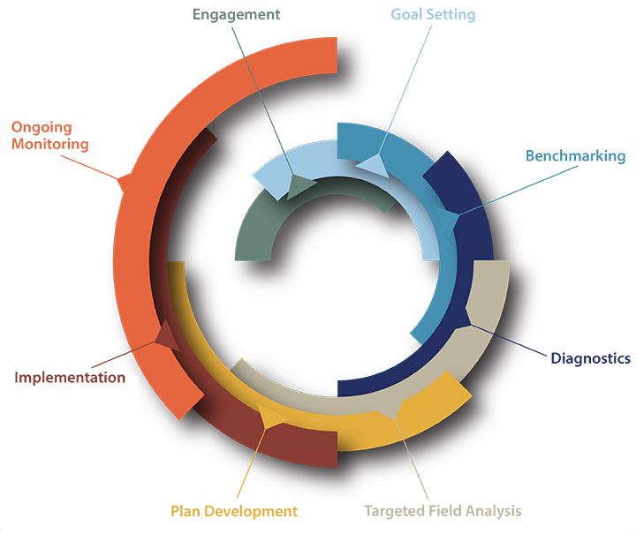
- Engage an energy champion and create an energy team
- Establish a vision with achievable goals and clearly defined metrics
- Benchmark energy usage
- Perform diagnostics
- Conduct targeted field analysis
- Develop a plan
- Implement energy saving measures
- Measure and communicate progress

- Stakeholder Engagement
The first step in the process is identifying and engaging municipal building stakeholders. This raises awareness and understanding of the value of energy management in a public buildings portfolio as well as the relationship of municipal building performance to broader policy goals. When high level officials, like City Council or School Board members understand the benefits and the significance of energy costs in the general fund budget, they are more likely to support the effort by allocating resources to develop and implement the plan. When department heads and facility operators have clear information about how well their buildings are performing and are given strategies to track and improve performance, they are more likely to manage their buildings more effectively.

The Energy Team and Energy Champion
A cross-departmental energy team can ensure that each aspect of Public Buildings Portfolio Management is addressed. Often, the Director of Sustainability or the Resource Conservation Manager serves as the energy champion, an overall point person who coordinates the effort. An integrated team of stakeholders often includes representatives from each department including the following areas:
- Department decision makers (e.g. Police/Fire, Parks and Recreation, etc.)
- Public Works and/or Facilities (including building managers and maintenance staff)
- Sustainability
- Information Technology
- Finance representative or decision maker
- Communications
- Executive representative (e.g. Mayor or City Manager’s office)
List the members of the energy team:
Example:
The _____City______ Energy Team is led by: Name, Title of Energy Manager/Sustainability Director/Resource Conservation Manager
Members include: (Examples)
- Director of Sustainability
- Building Energy Advisor
- Director of Facilities
- Director of Operations
- Utility Liaison
- Codes Department
- School Superintendent or School District Facilities Director
- Water Supply Board
- Director of Finance
- City Council Members
- Communications Director
- Policy Director
Describe how the energy champion inspires the team, staff, and decision makers:

Describe how the energy champion plans with the team to make energy upgrades happen:

Insert an organizational chart of municipal staff and decision makers:
Example:
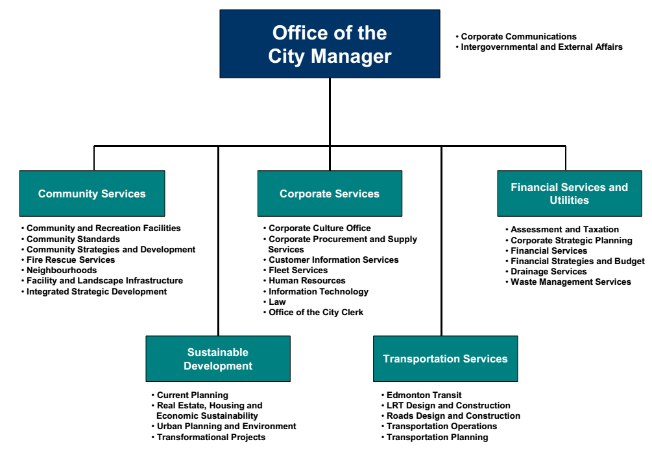

Energy Team Meetings
Regular meetings with the energy team are important to discuss projects, compare lessons learned, and share success stories across departments regardless of traditional operational or budgetary divisions. Establishing this formal mechanism for conversations and communications among departments and staff in the context of energy performance can lead to significant new initiatives, ideas, and approaches that support broad progress toward city goals.

Through this process staff members become empowered in efforts to reduce energy use. Those involved in facility management, renovations or new construction might share best practices that can be leveraged elsewhere in the city or school district. Involving the Information Technology (IT) group can lead to impactful reductions in energy consumption because networked devices, servers, and other IT equipment typically use a significant amount of energy and may offer scalable efficiency opportunities. The presence of the finance department is critical to help establish Return on Investment (ROI) criteria.

Many cities and other organizations have found that meeting monthly or quarterly is efficient and productive. In some cases, it may make the most sense to have a smaller group meet monthly and report out to a larger group quarterly or annually. When establishing meeting schedules and invitees, consider budget cycles and facilities master planning process timelines to ensure that energy is considered at the optimal time in the process to allow for effective implementation.

Describe the energy team meeting schedule: (example: Leads meet every 2 weeks, full team meeting one per month, every 6 months evaluate progress, annual presentation to City Council)

Stakeholder Drivers
Various stakeholders involved in the planning process have different drivers that impact how they make decisions. Knowing these drivers is helpful to consider when developing a rationale that best resonates with key decision-makers and staff. (Refer to the Public Building Portfolio Management Implementation Guide to see a range of potential drivers.)

Describe the stakeholders with a short explanation of their priorities or “drivers.” Here is an example of a Stakeholders and Drivers table, as can be found in the Public Buildings Portfolio Management Implementation Guide. Use this as a starting point to build your own Stakeholder Drivers table.

STAKEHOLDER DRIVERS
Stakeholder | Driver
City Council  Elected city council members are the primary decision maker for city facilities. They routinely seek input from the community, city staff, and a wide-range of consultants in decision-making and report back to the Mayor. | Priorities: Quality services, fiscal responsibility, citizen partnership, community pride, community partnerships, community livability  Votes and support of City Council members represent final decisions critical to city operations, city budgets and facilities.
School Board  Elected school board members are the primarily decision maker for school districts and school facilities. They routinely seek input from the community, students, staff, and a wide-range of consultants in decision-making. | Priorities: Education, 21st century skill development, fiscal responsibility, sustainability, positive school culture, social equity, community engagement, on time project delivery, accountability, student growth.  Votes of school board members represent final decisions on many topics critical to school facilities.
Facilities Department  The operation and maintenance of safe, healthy, and functioning city buildings is the responsibility of the Facilities Director. The Facilities Director may manage a group of staff that generally includes a team of Facilities Managers who are deployed across the city to various facilities to address specific maintenance issues and custodians. | Priorities: Dependable operation, ease of maintenance & operations, avoiding or addressing deferred maintenance, meeting budgets, safe environments, healthy environments, staff availability, and allocation.  Typically, the Facilities Director participates on the Long Range Planning / Facilities Master Plan development as part of the Leadership Team, alongside other stakeholders. While they are interested in energy, they are more interested in maintaining healthy and safe built environments. Their buy-in on new systems is critical to energy outcomes.
Sustainability Director, Energy Manager  Sustainability staff often work in association with staff and community members on a variety of “green” projects including energy efficiency upgrades. Some cities additionally have an energy manager that may work to tie the sustainability department to the facilities department through energy management and analysis. | Priorities: Energy/water conservation, emissions and waste reductions, healthy environments, upgrading facilities, reducing utility bills, social equity, community engagement, city pride, accountability, community growth, resilience.  Sustainability managers and energy managers hold critical information to understanding savings that come from conservation practices. They are very important to bring into the conversation early.
Department Leads  Department leads are responsible to council/Mayor on individual department performance and budgets. They may set building maintenance and upgrade priorities and/or deploy staff and building resources. | Priorities: Depend on the particular department (parks, fire, police, education, etc.), but generally they are focused on achieving department-level goals within allocated budgets.  Department leads are responsible for making decisions related to day-to-day operational policies as well as capital investment planning for their facilities.
- Goal Setting and Vision
Many communities have already defined their long-term vision and goals. The vision may be regarding community livability, air quality or climate protection. If so, the aim of the strategic planning process is to identify the role and opportunity that the public buildings portfolio represents to help meet these goals.
More cities are establishing goals specifically related to climate. Sometimes cities reference voluntary standards such as the STAR Communities program, the 2030 Challenge, or the Paris Accord. Other cities have their own reduction targets and timeline. For example, the City of Boise, Idaho has set a goal for all new construction and major renovations to be net zero by 2030 and for existing buildings to achieve a 50% reduction in energy use on average by 2030 compared to the baseline of 2010.
Setting more aggressive timelines for public buildings is a key demonstration of leading-by-example. For example, the State of California also has “Big Bold Energy Efficiency Strategies” including: zero net-energy residential new construction by 2020, zero net-energy commercial new construction by 2030, and net zero in 50% of existing buildings by 2030. To demonstrate leading-by-example, the timelines for these goals have been accelerated for state facilities. The California Department of General Services has a clear policy that all newly constructed state buildings and major renovations must be constructed to be zero net-energy starting in 2017.

Goal Setting
Goals define the path to success. Goals should be specific as to whether they impact the portfolio or the community. During the strategic planning process, the energy team provides context on how public building energy consumption relates to the overall community goals. Part of the process is to understand how much energy savings is possible in public buildings and what proportion of savings this represents across the entire community.
Outline any current goals, visions, policies, and resolutions that define energy targets for the city. These could come from sustainability reports, energy plans, city-wide resolutions, or statements from the Mayor. Include the following elements:
- Energy goals
- High priority actions to be undertaken
- Current status (if available)
- Policies & procedures in place to achieve goals
- Timelines for achieving these goals or reviewing/updating them\

Examples from a Sustainability Plan:
Goals:
- 30% energy reduction in municipal buildings by 2030
- Citywide carbon neutral by 2050
Recommendation: Lead by example and set a target for municipal buildings to be carbon neutral before 2050 when the target applies citywide. Consider a tiered approach of 50% by 2035, 70% by 2040 and carbon neutral by 2045.

High Priority Actions & Status:
- Develop an energy use baseline for all City-owned properties. This was completed in approximately 2013, and the staff are continually updating.
- Complete audits on City-owned buildings to identify energy efficiency opportunities. Staff has had Investment Grade Audits, walk-through energy audits, audits for solar potential, and scoping audits completed at many City buildings and schools, and continue to schedule others through vetted vendors.
Goals require clear ways to measure progress toward achievement, both in metrics (what) and methods (how). “SMART" (Specific, Measurable, Actionable, Realistic and Time-bound) is a helpful acronym to keep in mind when setting goals. In addition, interim targets break long timeframes into realistic segments and allow for celebrating successes along the way.
Consider the following framework for goal-setting that Boise created:
- Lead by Example through transparency, fiscal responsibility and high standards
- Inspire the Community through citizen engagement, public/private collaborations and incentives
- Build Resilience through promotion of resource efficient infrastructure, alternative fuels and renewable energy

Describe the long-term vision for municipal buildings with “SMART” interim goals:

Success Stories
Highlight 2-4 municipal building retrofits or new construction projects that achieved significant energy savings:
(Case studies available here: https://newbuildings.org/resource/public-buildings-portfolio-management/)

Describe how the success was achieved by detailing project specifications:

- Benchmarking and Data Analysis
Building energy benchmarking can lead to energy and cost savings for building owners. Fundamentally, benchmarking involves tracking a building’s energy performance over time, including grid-purchased electricity, onsite renewable generation, natural gas, district energy, and delivered fuels. Municipalities and school districts benchmark buildings to better understand their building stock, identify operational opportunities, and arrest performance drift. This can be done on the individual building or at the portfolio level to compare energy use or gauge performance in the marketplace.
Tracking building energy use over time can help identify the impacts of operational changes such as set points or lighting controls, maintenance work or capital improvements. Buildings benchmarked over a 3-year period showed an average of 2.4% annual savings in energy, according to information from the US EPA Energy Star® Portfolio Manager™ (ESPM) program. Ultimately, benchmarking can lead to informed decision making for building owners and operators, portfolio holders, building tenants and policy makers.
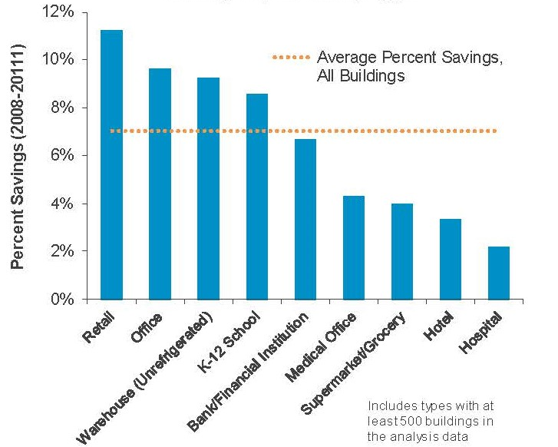
CAPTION: A study of 35,000 buildings that benchmarked energy data using the Energy Star Portfolio Manager tool showed an average percent savings of 7.2% over three years, or 2.4% per year. The impact was greater for certain building types, including offices and schools. Source: Energy Star Data Trends, Benchmarking and Energy Savings, October 2012.

A variety of tools are available on the market for energy tracking and benchmarking. Energy Star’s Portfolio Manager has the greatest market penetration. ESPM is a free tool that can be used to track data, generate reports, set goals, and effectively overview any number of buildings across many different building types. Tracking with ESPM can extend beyond energy to water, waste, and greenhouse gas emissions. Commercial buildings in cities with disclosure ordinances typically mandate Portfolio Manager to report and track energy consumption.
Benchmarking with ESPM involves the following steps:
- Set up a Portfolio Manager Account
  - Create a user profile.
  - Review the Benchmarking Starter Kit and other Portfolio Manager Training Materials.
Insert the administrator and login details:

Portfolio Manager Administrator(s):
Procedure for Updating Data: (example: update building data annually, energy data monthly)
Portfolio Manager Login:
Portfolio Manager Password:
- Collect Required Data on Buildings in the Portfolio
  - Inventory all buildings and key characteristics.
  - Identify where energy data will come from (utility bills, spreadsheet, automatic upload)
  - Identify energy meters and match them to each building. Seek out and identify cases with multiple meters per building or multiple meters on site.
  - Gather data for delivered fuels, if any (e.g. fuel oil).
  - Remember: garbage in, garbage out! Benchmarking must be based on consistent and accurate data sources.
- Enter Building Characteristics and Energy Data for all Properties
  - Add property data and building characteristics for each building. Review the Technical Reference Guide for more information about data entry and building parameters.
  - Energy data may be entered using a batch upload or one building at a time. Portfolio Manager provides excel templates for batch uploads (note, batch uploads can sometimes be challenging. Make sure to follow instructions on the provided templates.)
  - Alternately, users can enter data directly online. Finally, some utilities can transfer data directly from the utility to PM.
- Evaluate Results and QC
  - Once building data is complete, Portfolio Manager will graph your building energy use and show the EUI, GHG emissions, Energy Star score, and other metrics.
  - Confirm that energy usage patterns are accurate and that information is correct.

Energy Data Collection
Establishing a process for collecting energy data often requires more effort than originally expected. Ultimately, the energy champion is responsible for ensuring that the master building list is complete and that benchmarking data is accurate. By working with individual department directors, the champion can ensure that all buildings in the portfolio are listed.
An Energy Manager or other sustainability staff member can coordinate with the local utility to collect bill information. However, if there isn’t an Energy Manager on staff, this role might be filled with a committed energy team member or an intern. The AmeriCorps Energy Corps and Volunteers in Service to America (VISTA) programs are good resources for cities interested in finding medium-term volunteer staff.
It is critical to have the utility on board during the early stages of the strategic planning process. Utility staff can be helpful in gathering and transferring utility bill data into tools like ESPM. Many utilities have an automatic data transfer protocol. However, even when this is the case, care must be taken to ensure that meters are associated with the correct building and that all meters in that building are represented.

Master Facility Equipment List
Creating and maintaining a master list of all facility equipment helps department heads, facilities and operations staff, and planners anticipate future needs and align building upgrades with maintenance requirements. Centrally tracking existing equipment, including age and condition, enables and streamlines the implementation of equipment efficiency and performance standards.
Replacing equipment before it fails can yield benefits and avoid major problems. Utility HVAC incentive programs often pay substantially higher incentives for early replacement (that is, replacement of equipment that is still working) as opposed to replacement on burnout. This provides a financial incentive to replace (and upgrade) equipment that is near the end of its life rather than waiting for units to fail. Replacing units early can minimize maintenance and repair cost and also avoids last-minute expensive emergency equipment repairs and replacements.
Create a simple spreadsheet for logging equipment or consider the Maalka Lifecycle software tool or DOE’s Asset Manager Program. Key components of a facility equipment list are:
- Existing Equipment Location (facility)
- Type, model, description, etc.
- Capacity (e.g. tons of cooling, kBtu/hr. of heating)
- Unit Age or date installed
- Anticipated Life (total and remaining)
- Anticipated Replacement Equipment, by facility Location (facility)
- Type, model, etc.
- Capacity
- Efficiency/Performance Level
- Scheduled Installation

This is the kind of equipment often included in a Facility Equipment List:
- Rooftop HVAC Units and air handlers
- Boilers, furnaces, air conditioners
- Pumps and fans
- Building management systems and other controls

In some cases, if a building is a good candidate for a deep retrofit that includes a change in the HVAC system type (e.g. rooftop units to radiant distribution systems), planned replacement equipment may not be one-for-one.
- Diagnostics
Simply benchmarking a group of buildings, in and of itself, will not achieve energy and emissions reduction goals. Visualization and analytical tools can help transform this data into actionable information – and provide insights to inform the Community Strategic Energy Management Plan. The conceptual framework of this approach starts with a broad view of energy across the portfolio, zooms into individual buildings, and brings building-level diagnostic results back up to the portfolio level.

Step 1: Portfolio-Level Data Visualization
Gathering a building portfolio’s energy and building data in one place – that is, benchmarking a group of buildings – enables simple, easy-to-understand portfolio-level data visualization. The following charts show a few of the many ways to visualize portfolio-wide energy data.
The treemap diagram below shows the proportion of total city energy consumption by various individual buildings and building types. This quick snapshot of building energy use helps the energy team understand the relative impact of different facility types and departments on total portfolio building energy use. Diagrams like this help with evaluating upgrade opportunities with potential to achieve the most significant energy-use reductions.
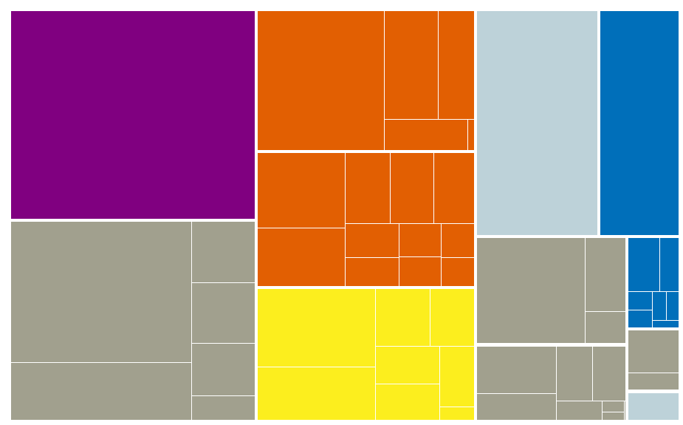
Theater
Repair Shops
Other
Wastewater Treatment
Offices
Police Stations
Parking Facilities
Fire Stations
Library
Storage Facilities
Public
Services
Museum
CAPTION: Relative Energy Use of Buildings in a Sample City Portfolio: Each small rectangle in this treemap diagram represents a single building. The size of each rectangle is representative of that building’s share of all energy use portfolio-wide. Buildings of the same type are color-coded into a shared box. In this case it is apparent that the wastewater treatment plant (upper left, purple) and the parking facilities (lower left, grey) together account for about a third of total energy consumption across all city buildings.
Adding building size and relative energy intensities into the visualization can help bring the picture into clearer focus. The following chart shows building size, annual energy consumption, and Energy Use Intensity (EUI) for the same group of buildings that is shown in the treemap above. Analyzing buildings based on their relative EUI can help:
- Identify poor performers
- Identify exemplary performers
- Determine to what extent building size is driving energy use
- Recognize the relative impacts of potential improvements in particular buildings
- Compare building performance to national, regional, or customized benchmark EUIs

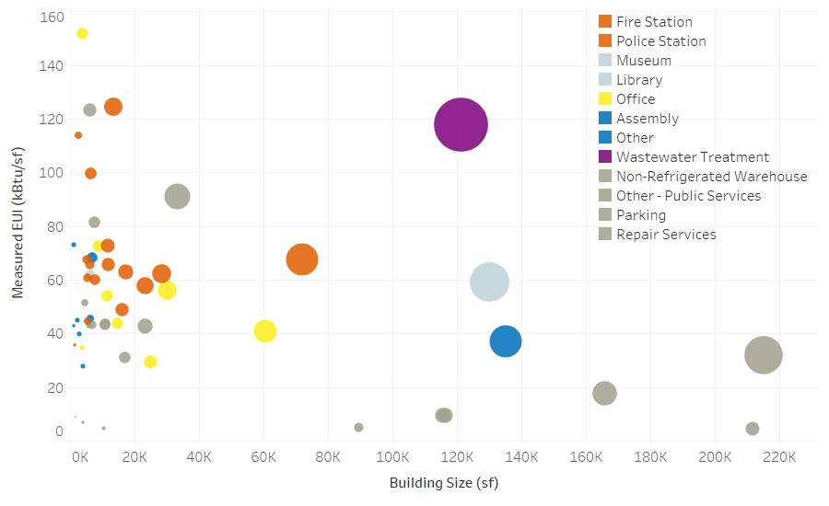
CAPTION: Energy Use Intensity, Size, and Total Energy Use of Buildings in City Portfolio
This bubble chart shows three building performance characteristics for each building. Larger buildings are to the right side of the figure (x-axis), and more energy-intensive buildings are farther up on the figure (y-axis). The size of each bubble indicates its total energy consumption: buildings with larger bubbles, such as the wastewater treatment plant (purple), have higher energy consumption.
The preceding two charts showed one year’s metered energy usage across a portfolio of buildings. The following chart shows another way to look at the same basic data. In this case, we see both weather normalized EUI and weather normalized total energy consumption for all facilities in a sample school district. The EUI chart (left) can help identify buildings that are not performing as well as their peers. The total energy use chart can help identify which buildings account for the largest shares of total energy use. Looking at both these data points at the same time is very helpful to identify top energy consumers and potential candidates for upgrades.
Weather normalization is a process used to adjust energy usage data to account for yearly differences due to weather. This is important when comparing data from one year to a preceding or following year, as is common when tracking performance against a goal. It is also helpful to compare one city’s buildings to a peer group in another climate zone.

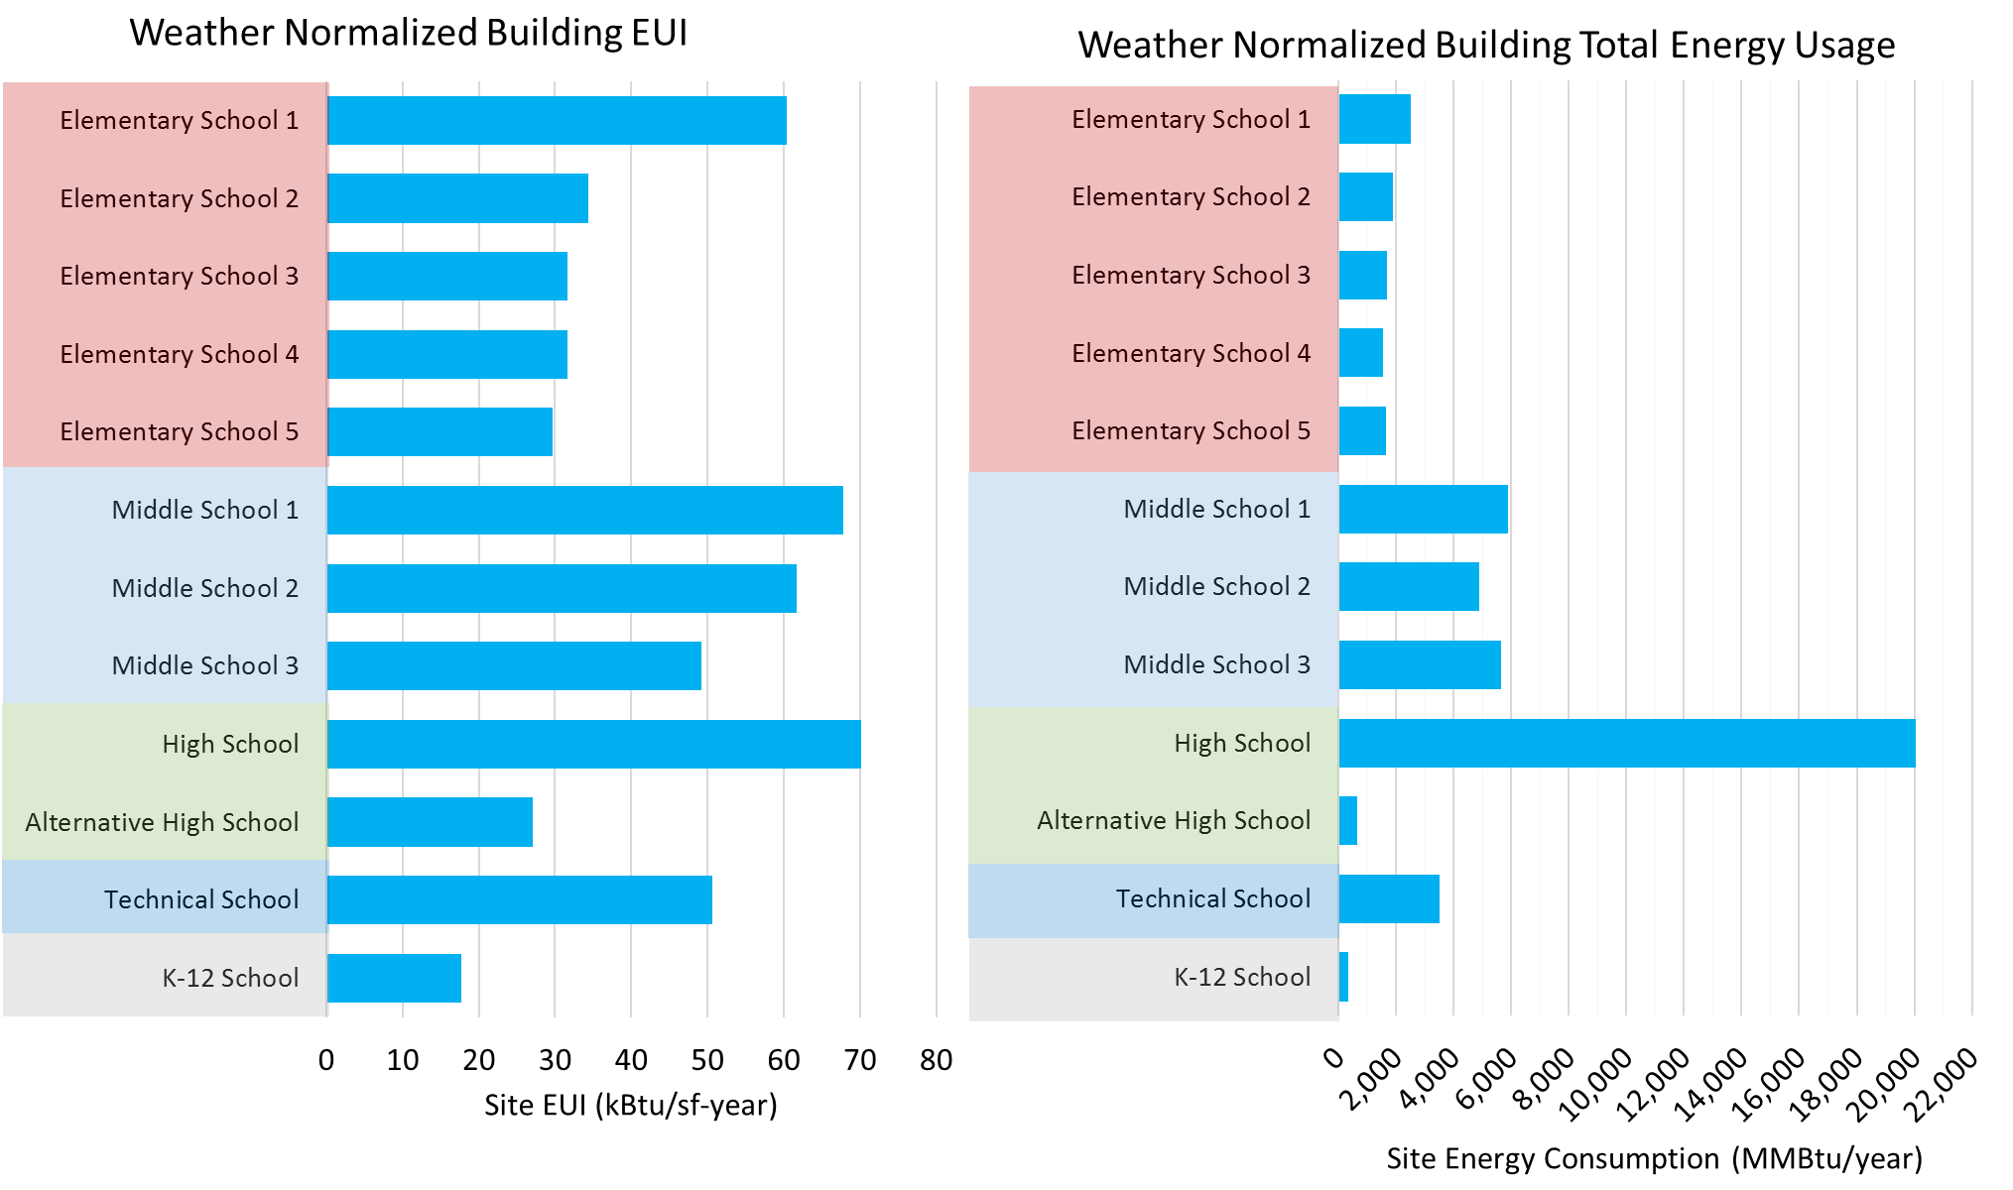
CAPTION: Relative and Total Energy Use for Buildings in a School Portfolio
These charts show EUI (left chart) and total energy consumption (right chart) for all schools in a school district. Elementary School #1 has a significantly higher EUI than the other elementary schools, but is responsible for a relatively small amount of the total district-wide energy use. On the other hand, the High School has far and away the highest overall energy consumption and also has the highest EUI.

Step 2: Building-Level Diagnostics
Remote diagnostics offer a way to further analyze benchmarking data in each building to uncover high priority opportunities for energy improvements without expensive sub-metering.

Energy Signatures
One useful way to visualize and evaluate energy patterns and trends is to use a graph called an Energy Signature. An energy signature is a plot of energy use at various outside air temperatures that provides a rough idea of how energy is used in the building at various weather conditions throughout the year. As expected, buildings use more energy when it is very cold or very hot outside than they do in more temperate conditions. Energy signatures can be developed using basic information: monthly utility bills, building size, and basic weather data. This chart shows an energy signature generated by plotting total energy usage (electric and gas are combined here) against the average outside air temperature for each month of the year.

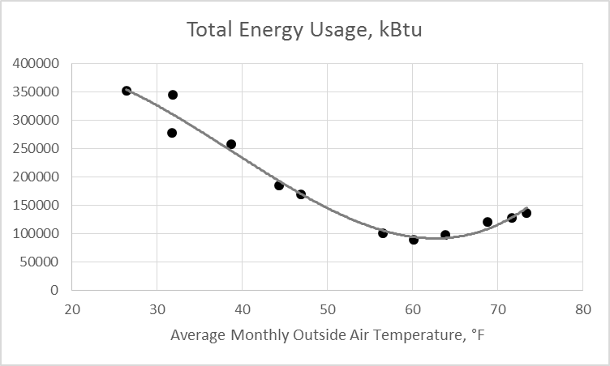
CAPTION: Building Energy Signature: This energy signature converts one year’s worth of utility bill data (kWh for electricity and therm for gas) into common units of kBtu, then plots total monthly kBtu energy usage against the average outside air temperature for each month.
A variety of software tools, including NBI’s FirstView®, can be used to remotely disaggregate benchmarking data into energy end uses and identify building-level opportunities. These virtual energy audits have become an important low-cost tool to define a prioritized list of buildings that deserve a walk-through building assessment. FirstView uses an algorithmic multivariable regression analysis to generate a physical model of the building and identify how much of the building’s energy consumption is associated with weather-dependent end uses (heating and cooling) or weather-independent end uses (lighting, plug loads, water heating, etc.). By comparing each building to reference benchmark values based on a large database of previously analyzed buildings, automated diagnostic recommendations are available to help identify areas of opportunity by end use in each building.
This template discusses results as if FirstView is used, but a variety of other tools are also available.
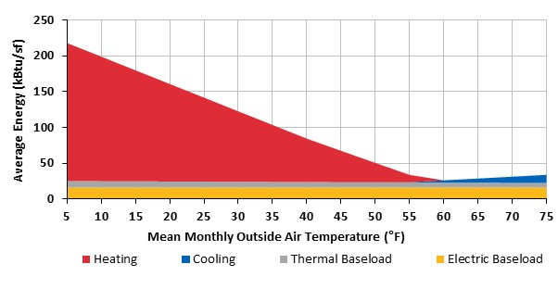
CAPTION: This FirstView output chart shows disaggregated energy by end use for a sample building. In this case, heating clearly accounts for most energy use in the colder months of the year, while cooling is a significantly smaller load overall, even in summer. The month of lowest consumption based on meter data is used to estimate electric and natural gas (thermal) baseloads.

Step 3: Portfolio-Level Diagnostics
Once buildings across the portfolio have been evaluated, and opportunities for operational and capital improvements have been identified, it is helpful to combine the results of those analyses into a broader view at the portfolio level. It can be useful to evaluate groups of similar buildings or city departments, as well as to evaluate all buildings across the entire portfolio.

Peer Building Comparisons
Building type and use influence energy use enormously. It is helpful to compare buildings to their peers: libraries can be compared to other libraries, fire stations to other fire stations, etc. In many cases these comparisons can be conducted at the department level. Many municipal departments include groups of peer buildings (e.g. fire stations). Cities, school districts, and other public building owners often have separate decision-makers for individual departments. Therefore, department-level comparisons can be helpful because they help streamline the analysis for a particular decision-maker.
This sample chart shows the energy signatures of five police stations compared to the range of typical performance for police stations based on NBI’s database. The yellow shaded area shows the middle two quartiles for police stations. This is known as a comparison spectrum.

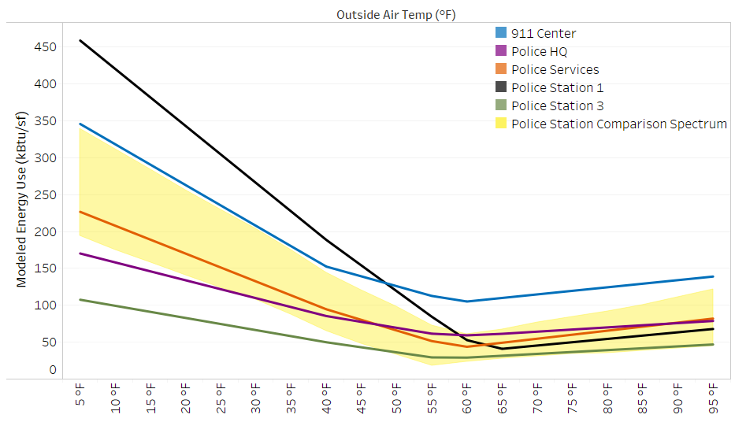
CAPTION: These five police stations’ energy signature lines tell a story of widely varying energy performance among the department’s facilities. The steep slope of the Police Station 1 energy signature (black line) indicates that the building is more sensitive to cold weather than its peers. FirstView and similar remote energy auditing tools can help flag potential problems with the building’s air-tightness, insulation, heating system, or ventilation rates. On the other hand, Police Station 3 (green line) uses less energy than the comparison spectrum throughout the year. As a top energy performer year-round, this building may be a good place to look to find exemplary operations, practices, and equipment.

End Use Disaggregation at the Portfolio Scale
The following graph shows the results of energy end-use disaggregation for a portfolio of office buildings. Potential opportunities at the building level stand out quickly. For instance, one building (circled in red) has an EUI very near the portfolio median value, and would likely not stand out on an EUI basis alone, but apparently has a much higher heating load than its peers. Similarly, three buildings (circled in grey) show unusually high thermal baseload usage and it may be worth looking for drivers of year-round natural gas usage in those buildings (hot water recirculation or HVAC reheat, for instance). The purpose of this analysis is to help prioritize building assessments in order to be strategic about energy efficiency investments.
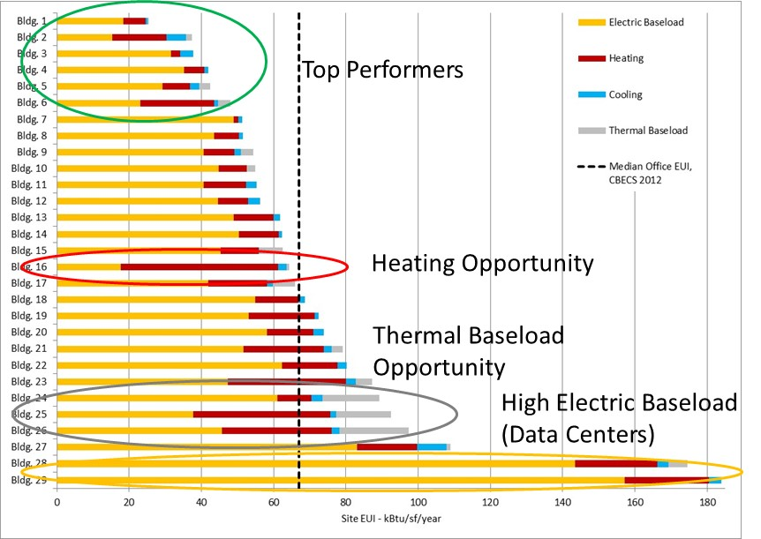
CAPTION: Disaggregated Energy End Use Data across the Portfolio: Examining disaggregated energy end use data for a group of buildings can help identify candidates for further investigation, including building assessments, and can improve the effectiveness of building assessments by identifying likely areas of opportunities.
Expand upon diagnostics and recommendations once portfolio analysis is complete
- Targeted Field Analysis
Using diagnostics to target specific buildings and subsystems can substantially reduce the scope of doing general field analysis such as targeted submetering, energy audits or building operator training across the entire portfolio of buildings. Instead, it is a more efficient and effective use of time and money to “target” a more limited number of buildings based on the priority level described below.

Facility Assessments
Beyond the performance issues identified during diagnostics, other building considerations may directly influence the timing and scope of potential energy upgrades. System maintenance and replacement issues, comfort and life safety issues and other factors can trigger opportunities for ECMs. Combining performance analysis with broader issues can leverage funding to serve multiple needs in the portfolio and make energy upgrades more likely and cost-effective when combined with other projects. There are prime opportunities for rolling ECMs into other projects such as deferred maintenance, equipment end-of-life, new construction, or major renovations.

Prioritize Buildings
Once data has been analyzed and needs assessed, the next step is to prioritize candidates for further investigation. Priority levels were defined to create a standard guideline across departments for identifying which buildings warrant deeper analysis and/or upgrades. Each department should be consulted for ranking their buildings based on their knowledge of any issues or plans for their buildings. The priority levels are 1 to 4, with 1 being highest, based on the following:
- Priority level 1 is based on high energy use vs. EUI target and/or high potential energy savings, high proportion of overall City energy use and/or high visibility—there is a strong reason to invest!
- Priority level 2 is based on moderate energy use, potential savings, or visibility; but this is a good candidate for upgrades.
- Priority level 3 is based on minimal reason to upgrade for energy reasons (either new or already very energy efficient or minimal potential to save energy cost effectively).
- Priority level 4 indicates a building in which no or minimal upgrades are worthwhile due to the condition of the building or uncertain future of the building
Insert departmental and building energy diagnostic results for top candidates

Field Analysis
As a general rule, target doing field analysis in priority level 1 buildings first.

Targeted Submetering
Some performance issues may require on-site submetering and deeper performance analysis to identify specific system failures that are driving poor performance issues. This work tends to be costly and time consuming, and should be focused on buildings with issues that cannot be resolved through analysis and diagnostics. Look for opportunities such as a tool lending library at Integrated Design Labs or through the utility to borrow submetering tools such as flow meters, power, and temperature loggers.
Energy Audits
Energy audits vary in depth, and ASHRAE provides well-respected standards for three levels of audits, which can be an important analysis tool when scoping major building retrofit projects:
Level 1 is a simple walk-through to identify low-cost/no-cost energy conservation measures (ECMs).
Level 2 involves a more detailed building survey, breakdown of energy use, and savings and cost analysis of ECMs.
Level 3 focuses on capital-intensive projects and includes more rigorous engineering analysis with a higher level of accuracy on cost and savings calculations.
The goal of diagnostics is to identify the subset of buildings that are good candidates for this level of effort, rather than spending significant resources auditing a wide range of buildings. It is also common that there are cost-sharing opportunities for energy audits through entities such as local utilities. Advanced energy audits can also include building an energy model of the building. This can be useful if major upgrades are being considered and there is a desire to weigh multiple options to determine those upgrades that have the best return on investment.
Advanced Building Operator Training
Consider sending facilities staff to training programs. Building Operator Certification classes are offered in Level I and Level II. Both offerings have a mix of hands-on projects and classroom lectures. This training encompasses all aspects of good building operation while highlighting the importance of energy reduction and occupant comfort. Such trainings can empower building operators by increasing their understanding of building systems and hands-on diagnostic tools. A link to training offered by the Intermountain Building Operator Association is www.intboa.org/building-operator-certification or to the national certification directly is www.theboc.info. It is also common that there are cost-sharing opportunities for this training through entities such as local utilities.
Describe the targeted field analysis planned for the next year: (include the vision, goals, strategies, and timelines)
- Implementation

Criteria for Existing Building Upgrades
Energy is an important consideration for jurisdictions when evaluating and justifying building upgrades, but in many cases, it takes a combination of energy and non-energy considerations to gain approval for capital projects. Just as in the prioritization process, energy savings should be considered alongside considerations such as:
- Occupant comfort, health, safety and productivity
- Maintenance requirements and costs
- Equipment end-of-life replacement opportunities - Many utility incentives do not apply if equipment fails.
Asking specific questions about proposed projects during energy team meetings can be a helpful way to identify key criteria and be sure that existing building upgrades under consideration are evaluated as holistically as possible. The following criteria is intended to enable everyone to be more strategic about building upgrades:
- Have operational and behavioral upgrades such as scheduling, reducing plug loads and thermostat settings been completed?
- Have low hanging fruit upgrades such as lighting been completed?
- Have load reduction upgrades such as air sealing and better insulation been completed or considered before larger capital investments (because load reduction can reduce the size of equipment needed)?
- Are capital improvements strategic and well planned to calculate ROI over the life of the equipment not just the upfront price?
- Is the emphasis on achieving heating efficiencies through more efficient HVAC systems, sizing, and distribution?
Two guiding rules for prioritizing which energy saving measures to do in which building are:
- Address operational opportunities first, then budget for capital upgrades
- Consider ROI (see section below).

Schedule for Upgrades
These may be specific energy improvements like an equipment upgrade or may also include indirect measures like staff engagement, purchasing procedures, etc. Regardless of the measure, it is recommended to assign timelines and responsible persons. Below is a sample table:
 | Upgrades / Recommended Actions | Estimated Completion | Person(s) Responsible | Actual Completion Date
1
2
3
4
5
6
7
8
9
10

Operational Policies
A building designed to high standards of performance relies on efficient operation to reach its potential. An operational policy across all buildings, at the department or jurisdictional level, can help maintain a high standard of operations and keep performance drift in check. It is important to find the fight balance between energy efficiency and occupant comfort and productivity. Energy efficiency is not freezing the dark!
Typically, an effective operational policy covers the following categories:
- temperature setpoints and natural ventilation
- plug loads
- lighting
- staff awareness recommendations and policies
(Refer to the Public Buildings Portfolio Management Implementation Guide for a sample operational policy.)
Describe an operational policy that could be appropriate for occupants:
(See these operational and educational policies as a resource: https://www.energy.gov/eere/slsc/energy-efficiency-policies-and-programs)

ROI Analysis for Capital Investments
Return on Investment (ROI) analysis presents a more comprehensive picture than simple payback to evaluate and prioritize upgrade opportunities. Many leading organizations require ROI analysis as a key part of Requests for Proposals (RFPs) when seeking bids for work on buildings. ROI should reflect financial and environmental priorities for the organization and is typically based mainly on simple payback. A more comprehensive approach includes simple payback, opportunity cost, maintenance savings, occupant satisfaction, comfort, waste reduction, and other factors. Life Cycle Costing Analysis (LCCA) is a very useful tool to evaluate the true costs and benefits of long-lived public assets like buildings and their components and systems. Contractors should be required to provide an estimated ROI that is ideally based on LCCA before being selected for projects.

Tracking Energy Efficiency Upgrade Impacts
Tracking the impacts of energy efficiency projects as they are implemented helps decision makers see benefits of spending limited time and money on energy efficiency. It also helps the energy champion communicate success stories both internally and externally to the community at large. Consider a simple chart like the one below or one of several software tools that are available to track measures such as ESPM or Maalka.
 | Energy Efficiency Upgrade | Date of completion | Pre-upgrade energy use* | Post-upgrade energy use* | % Change | Non-energy impacts
1
2
3

Zero Energy Building Candidates
Zero energy buildings (those that produce as much energy through onsite renewables as they consume over the course of a year) can be a great way to create buzz for city efforts to reduce energy. A ZNE building can also be positioned as a way for a community to provide a self-sustaining, resilient refuge during hazardous events.
List the most likely project candidates based on analytics and renewable energy potential:

Performance Standards for New Buildings
If, for example, aligning with the 2030 Challenge is the objective, this means adopting performance goals for new buildings that equate to being 70% more efficient than the 2003 CBECS. A good reference is the NBI Getting to Zero Buildings Database (https://newbuildings.org/resource/getting-to-zero-database/), which contains over 600 examples of these types of projects across North America. Refer to the high-performance building specs in Appendix A. If LEED is the performance goal, then consider a corresponding EUI target that more specifically defines energy performance than the LEED minimum of being 5-10% better than code.
Describe performance standards for new buildings:
(Example: LEED Gold, with an EUI less than or equal to 25 kBtu/sf/yr for all new construction)

Financing Mechanisms
A wide range of funding opportunities are available and project budgeting will depend on a community’s accounting processes. It is important to begin with a solid understanding of current processes before considering new and innovative approaches. Critical questions to ask include:
- Are budgets managed centrally or at the department level?
- Are utility bills managed centrally or at the department level?
- Will project funding be transferred out to the department who then manages the funds and potentially the project or will central management of the project implementation be maintained?
Financing Mechanism Examples include:
- Utility Rebates and Incentives
- Bonds
- Performance Contracting
- Grants
- Revolving Energy Funds
Incentives, often from utilities and energy efficiency program implementers, and grants are available. These not only help to reduce costs but can also serve as good indicators of which projects are cost effective because most utilities are required to analyze the cost effectiveness of a measure before being able to provide an incentive for it.
Revolving Energy Funds (REF), also known as Revolving Loan Funds can be a very powerful tool to help institutionalize energy upgrade projects across an organization. REFs can use either internal or external funding sources. In an internal REF, a fixed pool of capital is set aside to pay for energy upgrades. Some or all of the utility cost savings from those projects are used to fund additional projects. Some mechanisms often used to create internal REFs include:
- Establishing a budget line item for a fixed number of payments into the Energy Fund
- Contributions from Capital Budgets of all departments that will benefit from use of the fund
- Establishing a fixed or percentage “utility surcharge” that all departments must pay in addition to their utility bill
Many external REFs are administered by states: more than 30 states have established loan funds for energy efficiency and renewable energy upgrades. The benefit of using an external REF is that budget dollars do not need to be set aside to launch the Fund. However, interest rates and terms vary significantly among external REFs. In some cases, projects have had success leveraging internal funding with external REF resources by using the internal funding as a credit enhancement.

City | REF Formed | Initial Funding | Sustaining Funding | Managed By | Model | Project Criteria | Repayment Basis
Ann Arbor, Michigan | 1998 | $100k/year for 5 years, from City's General Fund | 80% of projected (energy audit) avoided costs for 5 years | Energy Office; Committee oversees project selection | Grant | 3 funding categories:  70% Direct savings, max 5 year payback  20% educational  10% data gathering (e.g. audits) | Projected avoided cost*
San Jose, California | 2005 | $200k utility incentive rebate; $60k from city depts. | 100% of projected (audit) avoided costs for 2 years; utility incentive rebates | Environmental Services Department | Grant | Projects must have payback ≤ 5 years | Projected avoided cost
Hillsboro, Oregon | 2010 | $28k prior energy efficiency project; $23k facilities management budget | 50% of projected (energy audit) avoided costs in year 1, 25% in years 2 and 3 | Sustainability Manager; Committee oversees project selection |  | Projects capped at $25k, larger projects must demonstrate avoided costs | In-house cost avoidance calculations
*Repayment was originally based on actual avoided costs but was changed to projected avoided costs. The city cited both difficulties in measuring savings and delays in accounting processes resulting from waiting for actual energy performance data as reasons for making this change.
CAPTION: Three examples of Energy Funds from cities around the nation. Source: Allegheny Science & Technology.
Describe the type of financing mechanisms available and/or brainstorm new options that could be appropriate:
- Ongoing Monitoring
Organizational goals inform and help define energy and climate targets. Tracking performance against those goals, at the portfolio level as well as the facility level, is key.
Reporting is essential to communicate progress, to share successes and lessons learned, and to ensure transparency with the public. Consider the following audiences for reporting:
- Administration (Mayor, City Council, and department heads) – interim reports on progress towards goals
- Decision Makers (City Council) – annual report just before budget season
- Community – annual energy
Consider the format and frequency of reports, both external and internal. Most organizations tend to report on performance against targets and goals monthly, quarterly and annually. What level of detail is meaningful to each audience? For example, management may want quarterly reports that show year-over-year comparisons of energy use and cost per building and for the entire portfolio. Facility staff may want monthly reports that show daily variations as well as overall trends year-over-year. External reports such as annual city planning reports intended for citizens often publicize goals, projects, incentives, and metrics such as EUI and shows rankings of buildings with a percentage change in energy use or cost versus the prior year(s). Rather than creating a standalone energy report, consider adding energy and climate targets as a standing agenda item or line item in an established regular reporting structure, for instance a Sustainability Report.
Describe the reporting that will be done to communicate energy performance results internally and externally:
- Who is your target audience?
- What metrics will be used?
- How will you compare goals to current performance results?
- More….

Occupant Engagement
Beyond the energy team, consider how to raise awareness and understanding of the value of saving energy. Help occupants and staff understand the impact their choices have on building energy use and what they can do to help achieve energy and climate goals. For example:
- Dashboards
- Trainings
- Activities and competitions
- Recognition programs
Describe how occupants and staff will be engaged:

Community Engagement
There are many options for engaging the community:
- Citizen advisory group
- Student government
- Email newsletter
- Website dashboard
- Dashboard in buildings
- Benchmarking data in curriculum (for schools)
- Codes/incentives
- Disclosure ordinances
- Neighborhood or business associations
- 2030 Districts

Describe how the community will be engaged:
- Conclusion
Briefly reiterate the next steps and the plans for this step forward on the path to high performance.

- Resources
Cite referenced resources

